Shakespeare in Fragments

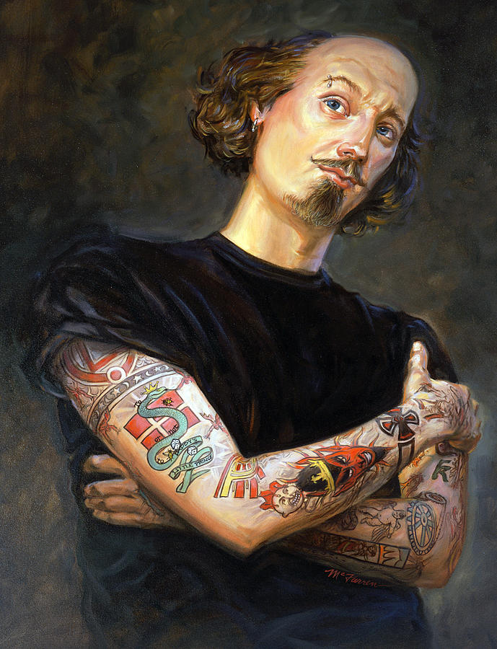

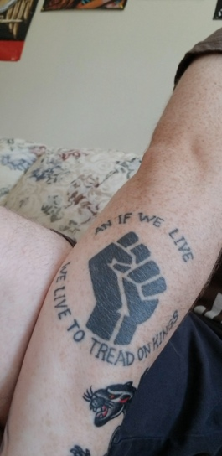
As we will discuss in class, we very often experience Shakespeare in fragments or, as Emma Smith would say, with "gappiness." The plays, like Shakespeare's life, are often subject to gaps or fragmentation. In this assignment, we will be spending time thinking about what fragments you find the most interesting. Very often, parts of Shakespeare's plays end up as tattoos--as you can see below. For this assignment, you will be collecting tattooable quotes from the four plays we will be reading, talking about why you think they are tattooable, and turning a couple into actual tattoo designs.
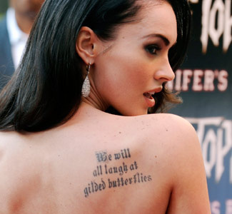
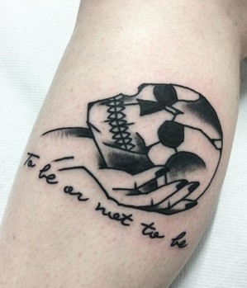
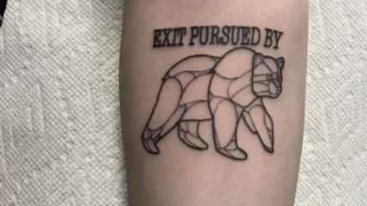

Quotation Collection:

For weeks 2-5, you will be responsible for choosing two quotes from each of the assigned plays and writing a short write-up about why you like each quote, and why you think that they are tattooable.

Please create a Google Docs file to catalogue your quotes in. You only need to create one Google Docs file that you will continually resubmit with updates. Please make sure that you have shared it with me and/or have made it viewable for anyone with a UC Davis email.

When choosing quotations, you should try to pick quotes that are not already immensely popular. For instance, choosing "To be or not to be" or "Arise, fair sun, and kill the envious moon" will not be as rewarding or engaging as picking quotes that you genuinely enjoy, find funny, identify with, etc. Your two quotes should also illustrate breadth. You should not pick two quotes from the same scene, and you should try to not pick two quotes from the same act. I need to see that you have engaged with the entirety of the play and taken the time to read and chose your quotations.

Specifications:

Each week, pick two quotes from the assigned play and write up a ~100 word justification for each quote that discusses your rationale behind your choice.

Due Dates:

- Coriolanus Quotations due July 6th by 11:59pm
- Romeo and Juliet Quotations due July 11th by 11:59pm
- Twelfth Night Quotations due July 17th by 11:59pm
- Cymbeline Quotations due July 25th by 11:59pm

Final Tattoo Designs:

Please take one of the quotations that you have previously picked and turn it into actual tattoo design. As you can see from the examples, your design can have an image or just be text--the choice is yours! Remember that the inclusion or lack of an image is an intentional choice. You will also want to think about text font, color, text/image size, body placement, etc. In addition to designing a tattoo, please write up a 300-350 word justification of your design. You will want to discuss why you picked the quote from your pre-established list, what design choices you made, and why the tattoo is relevant--this relevance could be personal, political, environmental, etc. Please keep in mind that we will be sharing these in a Canvas discussion board, so be mindful that your design will be seen by everyone in the class.

Due: Thursday July 27th by 11:59pm

